You can make your
donation online at
www.brightfutures.com.au
or see the attached letter for other options.

SEVEN SACRIFICES IN SEVEN DAYS
'Seven Sacrifices in Seven Days' is a very simple idea.

Proceeds from Seven Sacrifices in Seven Days will go to support

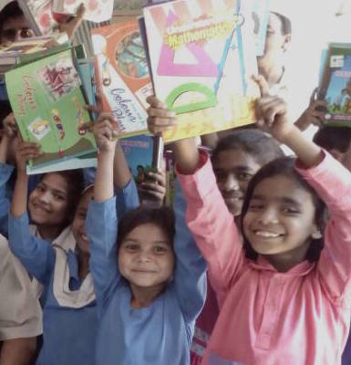

children’s education in
Pakistan and India,

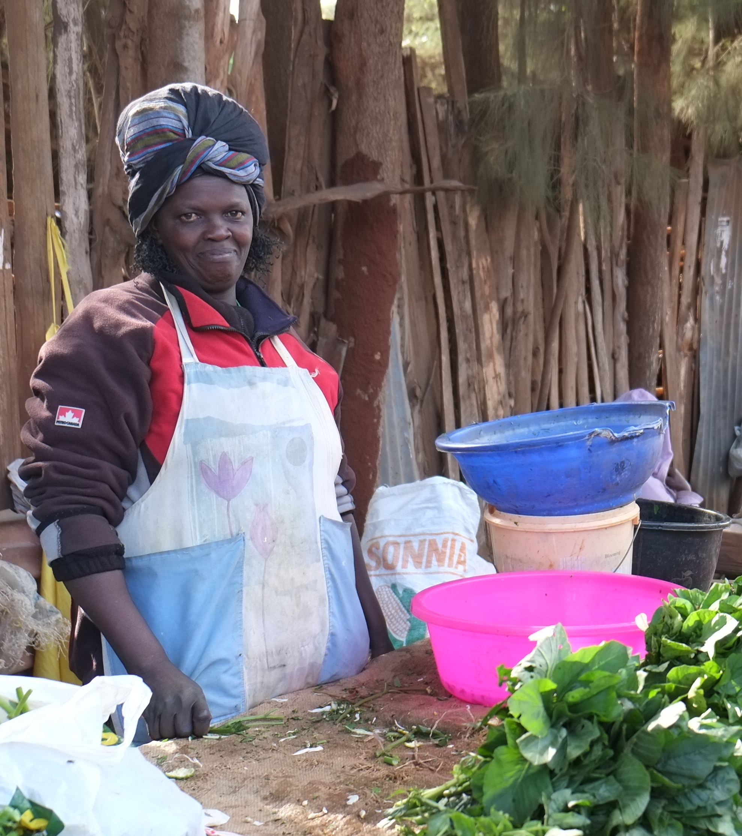

the empowerment of
women in Kenya,

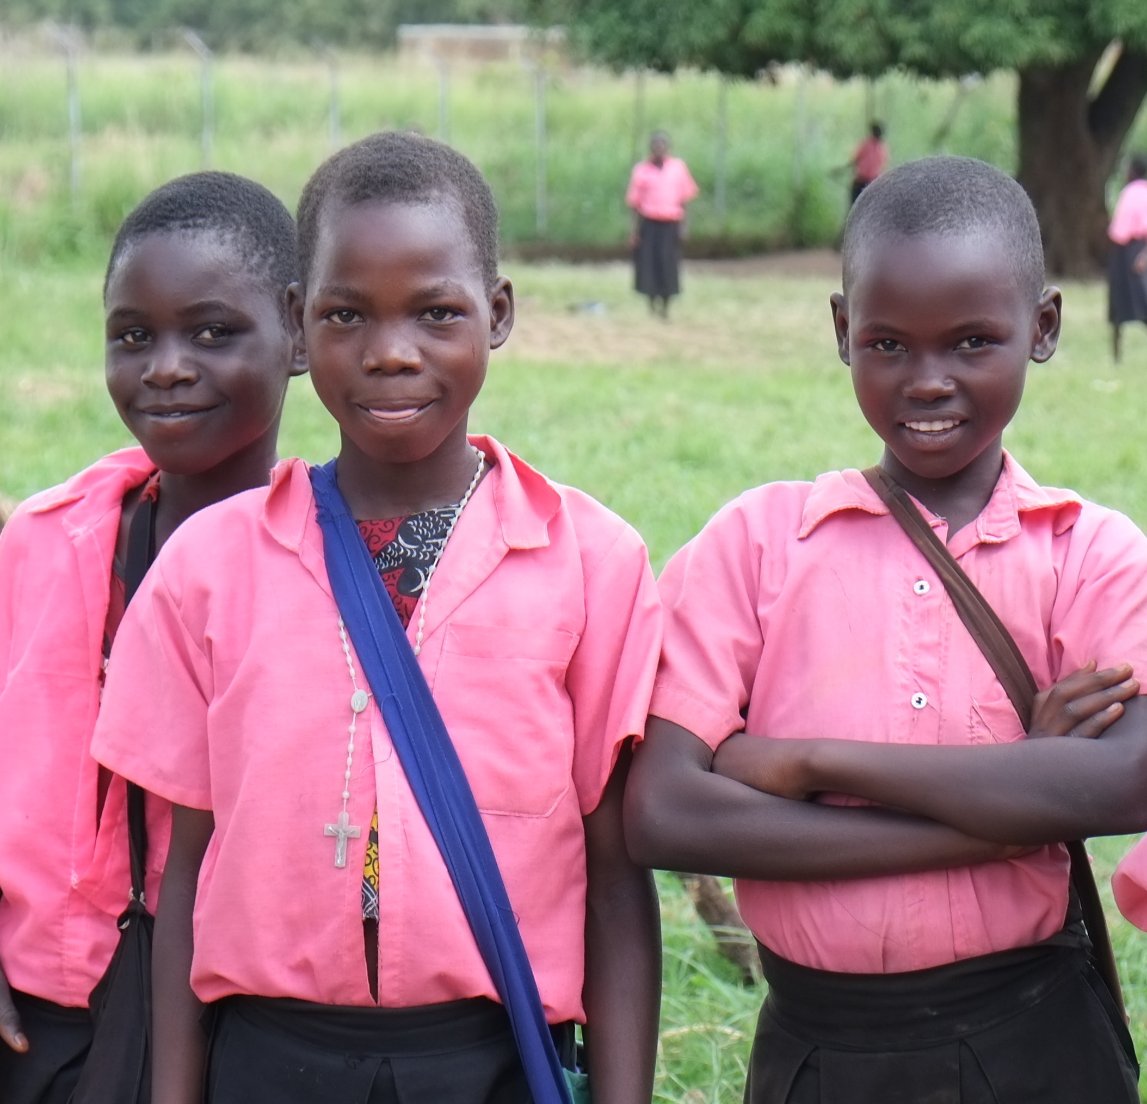

& healthcare in Uganda.

Each day next week, starting on Sunday, 18 June, we ask you to sacrifice something that
comes at a cost (eg bought coffee or lunch, movies, chocolate!) and donate what you save to
help some of the world’s poorest people in India, Pakistan, Kenya and Uganda.

Another way you can do it is to ask a friend or family member to sponsor
you to give up for the week something you really like (eg a favourite food, drink, TV show,
Macca’s- the possibilities are endless) with the sponsor funds being donated to help.

Whichever way you choose to do it, your sacrifice will make a big difference.

Want to find out more? Go to www.brightfutures.com.au or the Bright Futures Facebook
page: www.facebook/BRIGHTFUTURES.AUS

(Track your sacrifices here) Name: ______________________________________
Date | Here’s what I sacrificed! | Here’s what I saved so I could donate and/or here’s what my sponsors contributed.
Sunday
18 June 2017
Monday
19 June 2017
Tuesday
20 June 2017
Wednesday
21 June 2017
Thursday
22 June 2017
Friday
23 June 2017
Saturday
24 June 2017
 | My Total Donation Amount:
DONATIONS OVER $2
TAX DEDUCTIBLE

Bright Futures Child Aid & Development Fund Australia

1 Collingrove Avenue,
Broadview SA 5083
08 8342 4426
office@brightfutures.com.au
www.brightfutures.com.au

Executive Officer:
Paul Madden

M: 0411 740 549

E: paul.madden@brightfutures.com.au

ABN 76 803 488 074

SOME simple SACRIFICES THAT MIGHT WORK FOR YOU!

- Love coffee or chocolate? You could forgo these treats on one or more days.
- Maybe hold back on that trip to the movies and wait for the DVD (or not)!
- Take your lunch to work instead of buying it at the café.
- Instead of going out for dinner with friends just invite them over for a simple supper.
- Regular book or new clothing buyer? How about giving it a miss for a week.
SOME THINGS FRIENDS/FAMILY MIGHT SPONSOR YOU TO GIVE UP
For the week!
- A favourite foods - eg biscuits, chocolate, cakes, sweets
- A favourite drink - eg soft drink, coffee, wine, beer, smoothies
- A favourite TV program or activity – the possibilities are endless. Only you will know what is a real sacrifice to you.
You can help us by posting your suggestions on the Bright Futures Facebook
page - www.facebook.com/BRIGHTFUTURES.AUS and don’t forget to let us know by email or on Facebook what sacrifices you are making during ‘Seven Sacrifices’ week.

